*Samsung mobile*

*SAMSUNG GALAXY A14*

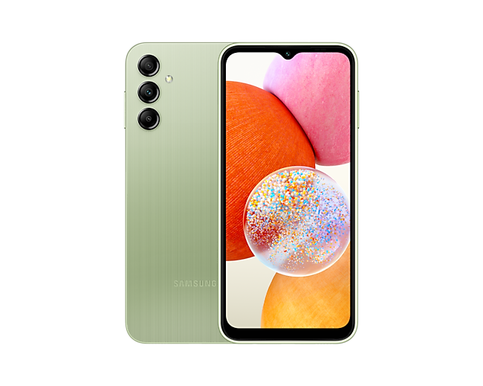

Awesome Signature Design 6.6" FHD+; Rear Cam: 50MP Main + 5MP Ultrawide + 2MP Macro; Front Camera with Upgraded Selfie (13MP); Long-lasting 5000mAh battery.

**PRICE /10,00.00 PRK**